**LIT ASSIGNMENT - DAY 12- ADOBEFORMS**

**DATE : 17 September, 2022** **Batch: SAP ABAP ON HANA**

**EMP ID: 46255236**

Created INTERFACE IN SFP:

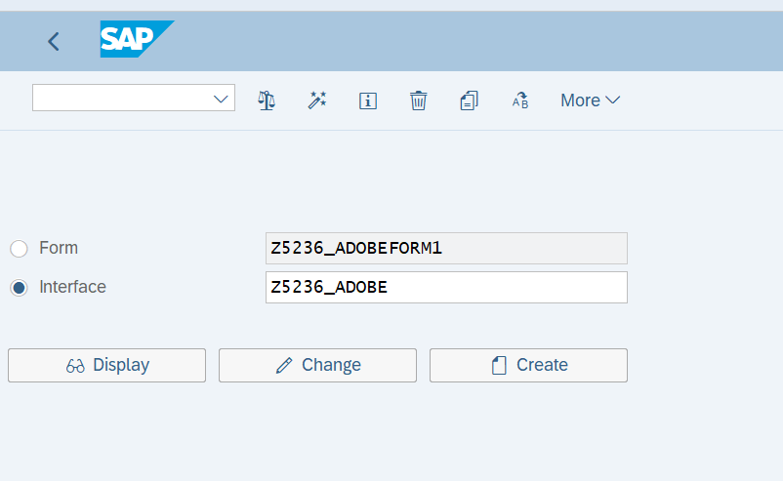

Dynamic text field importing:

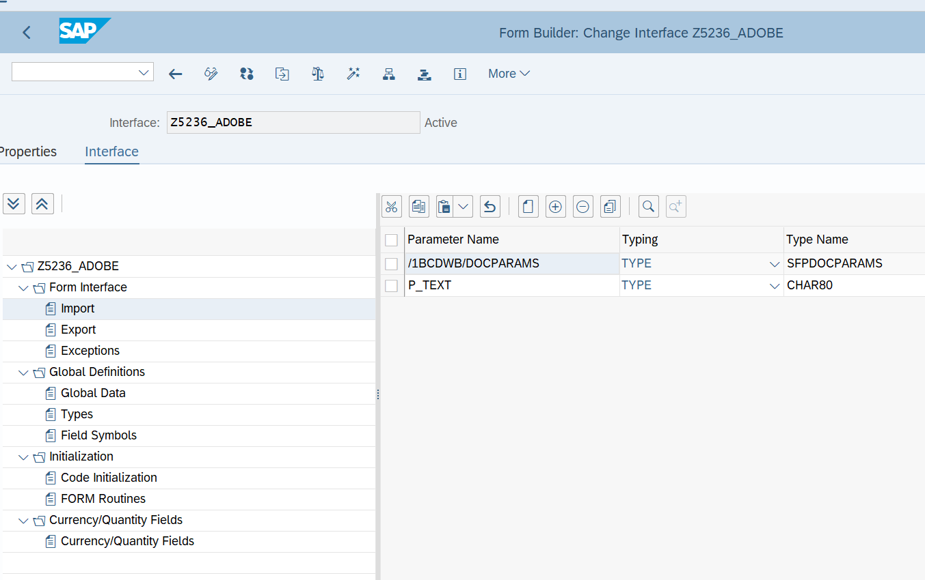

* Logo Parameter AND internal table field inserted in Global data.

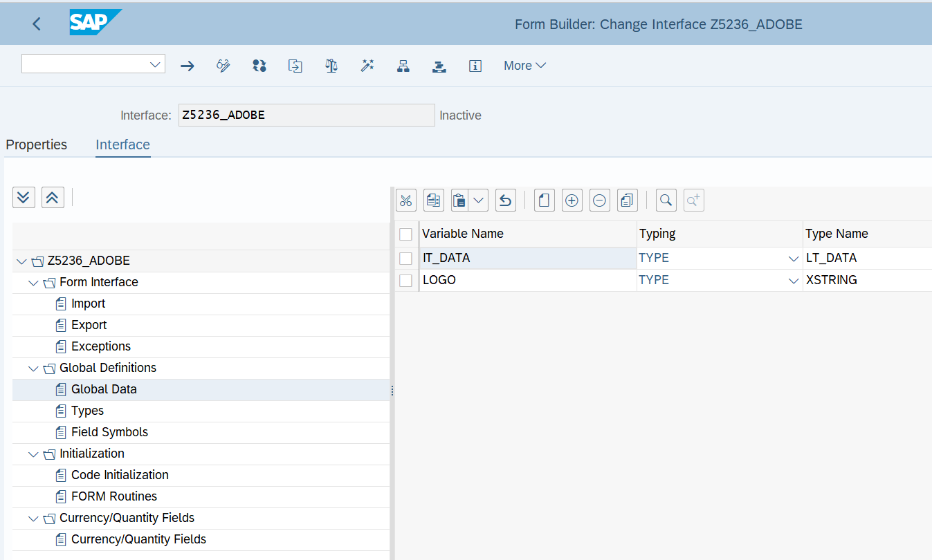

Select Query:

SELECT A~carrid,  
        A~connid,  
        B~CITYFROM,  
        B~CITYTO,  
         C~BOOKID,  
         C~CLASS  
  FROM SFLIGHT AS A INNER JOIN SPFLI AS B ON A~CARRID = B~CARRID INNER JOIN SBOOK AS C  
                                                 ON B~CARRID = C~CARRID INTO TABLE @IT_DATA.

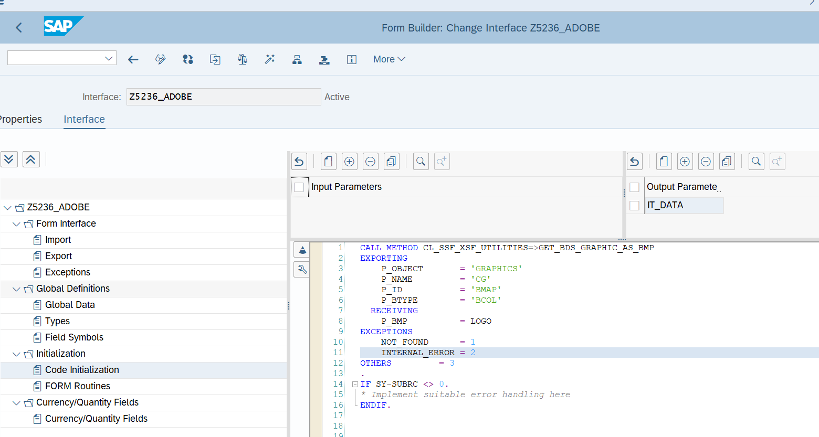

ADOBEFORMS:

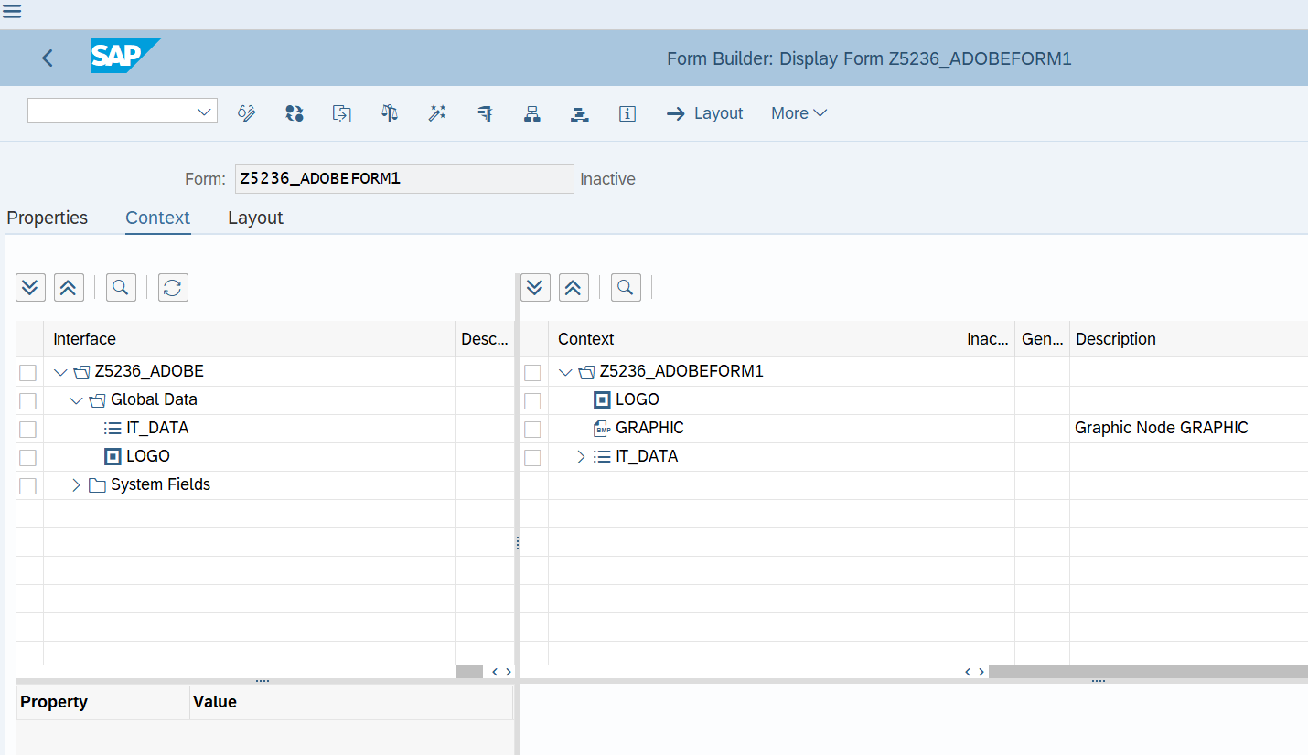

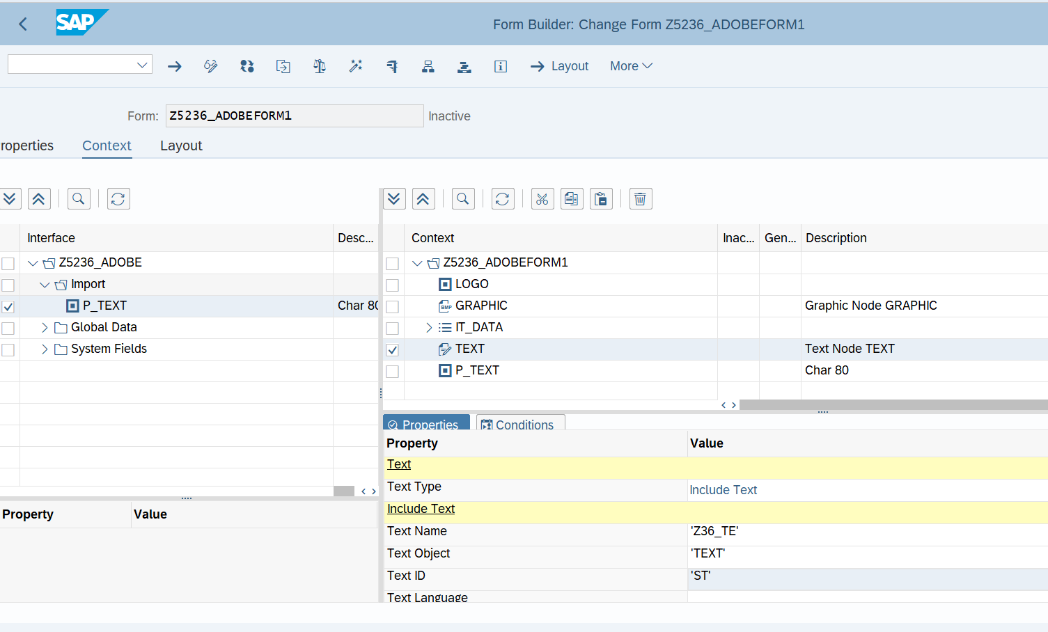

Layout:

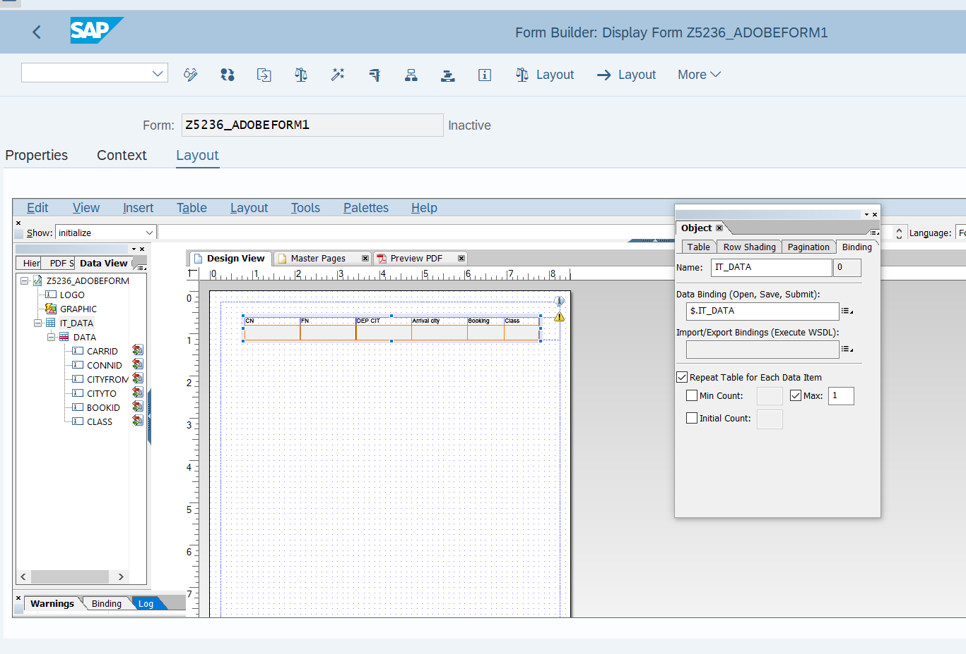

* JavaScript in adobe forms and display Logo only on first page.

var curpage = $layout.page ( ref ( $ ) )

if ( curpage ne 1 ) then

$.presence = "hidden"

endif

* JavaScript in adobe forms and display Footer only on Last page.

var curp = $layout.page ( ref ( $ ) )

var totalp = $layout.pageCount()

if ( curp ne totalp ) then

$.presence = "hidden"

endif

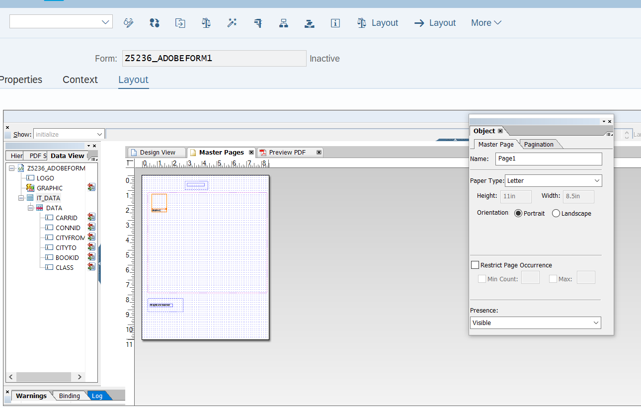

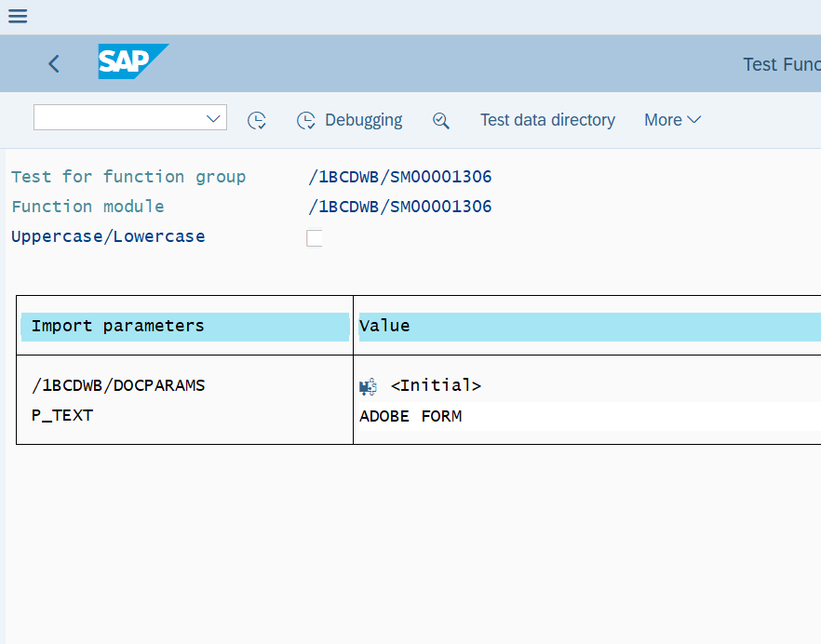

**OUTPUT:**

